Spring Actuator

Actuator offers production ready features when we deploy our application on to production server then it becomes necessary to monitor the health of the application. To enable this feature in our application we need to add dependency for actuator

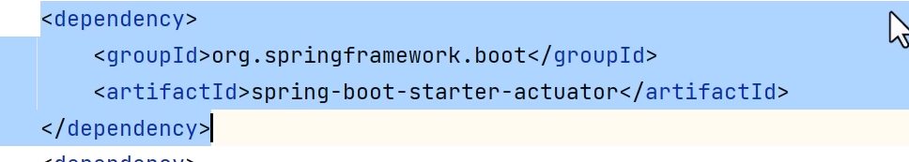

Not all the actuator related end points will be enabled due to security purposes

Now when you try to access the path localhost:8080/actuator you may get loginscreen if you have enabled spring security. You can disable this by below

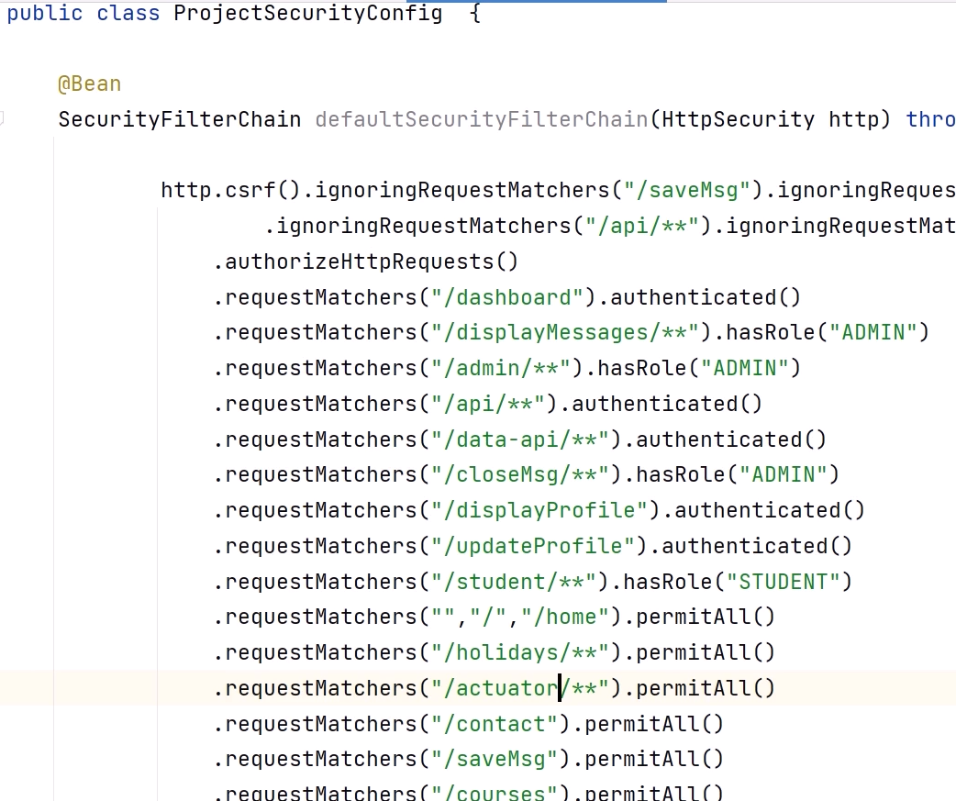

Now once you do this you can now access actuators

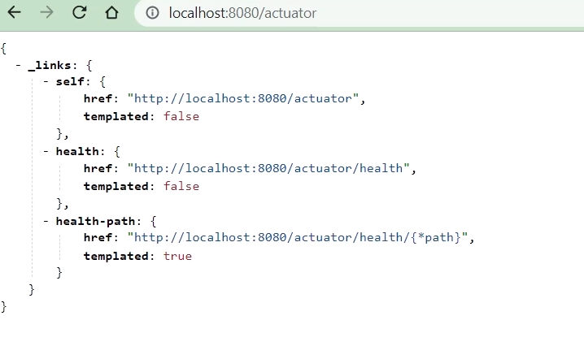

Now its very limited information we may want some other information. this can be done by defining properties in properties file

We can define custom path as well

Define properties to expose all actuator endpoints

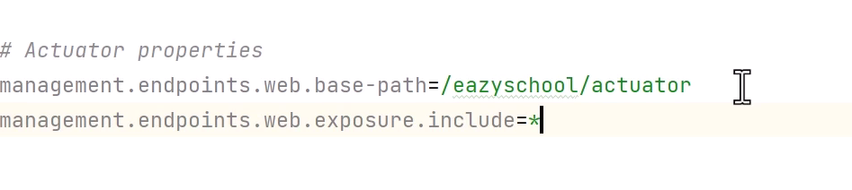

As this is a sensitive information we need to provide some security

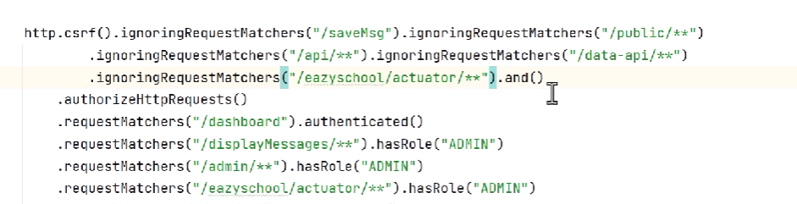

Now open the path you will be able to see lot of information

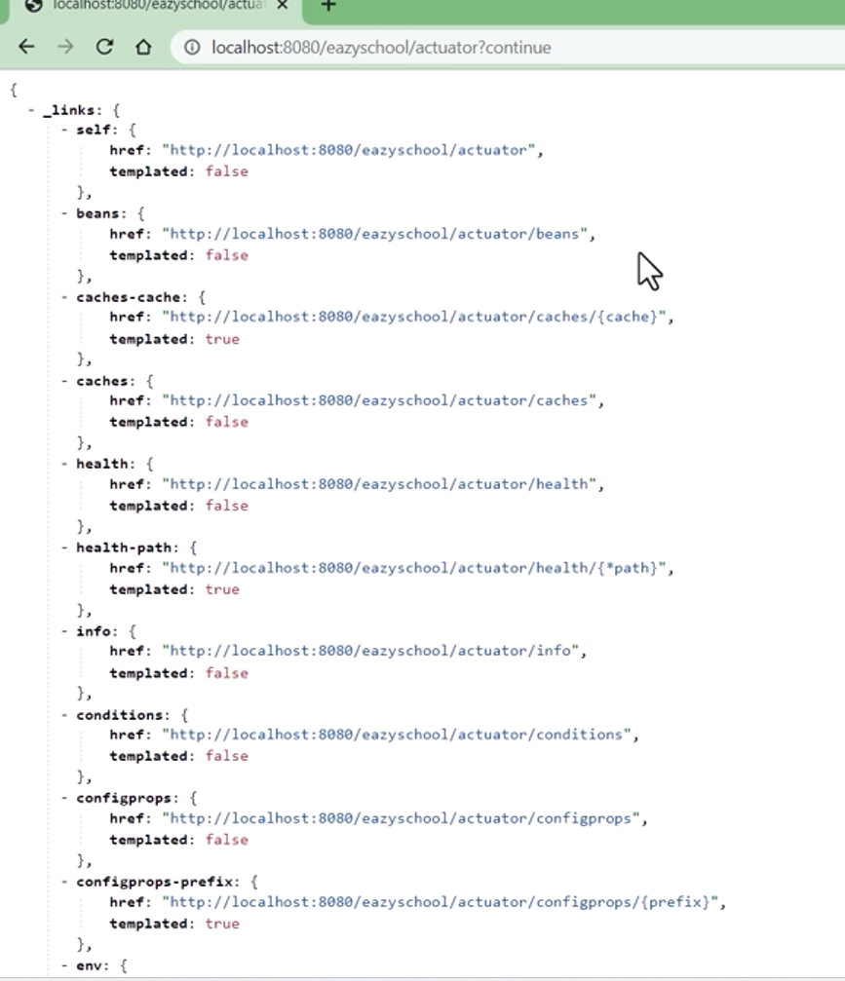

API or endpoints provided by actuators

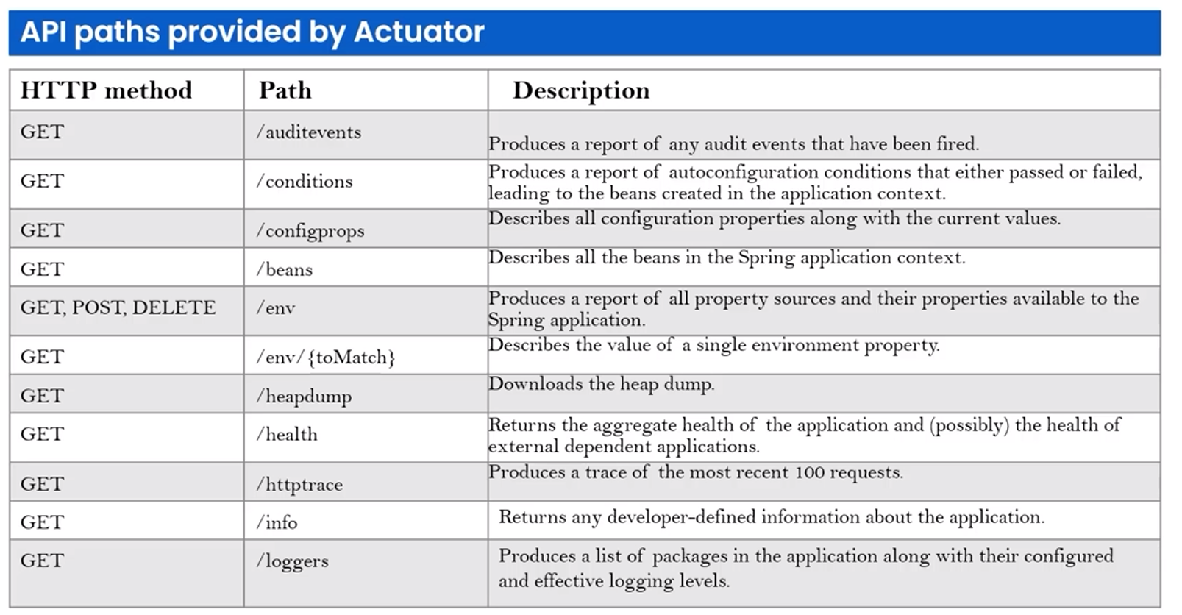

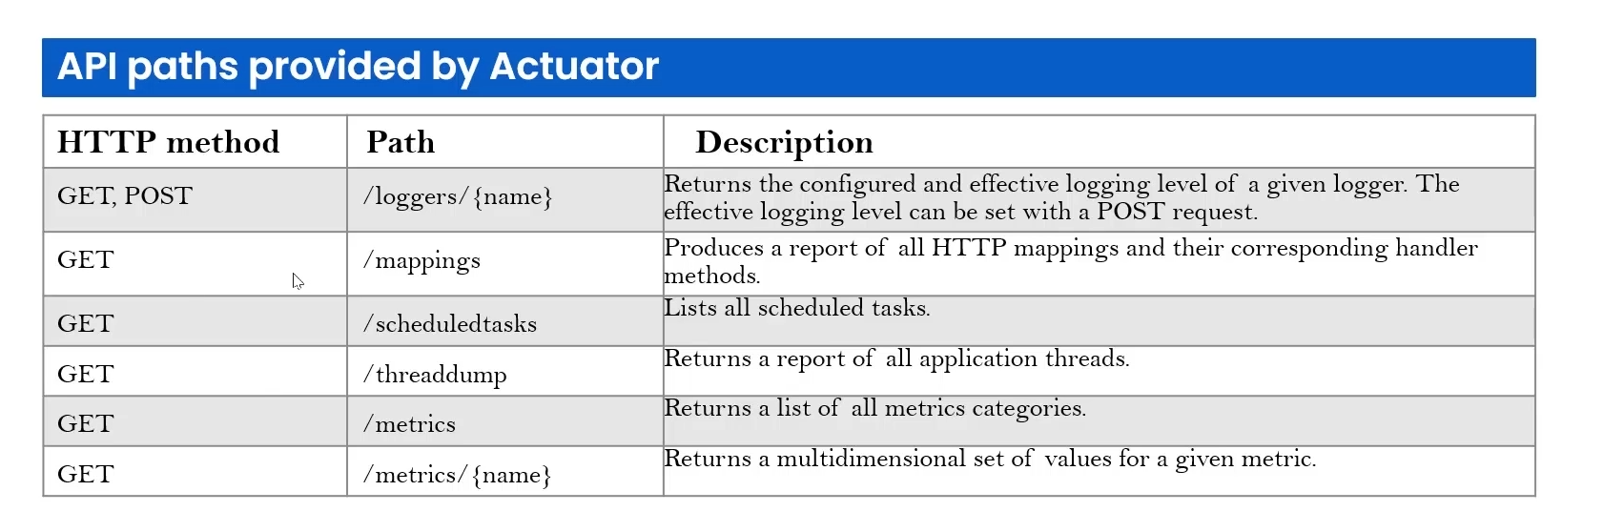

Now we may also want to maintain the application info like info version this can be done in defining the class

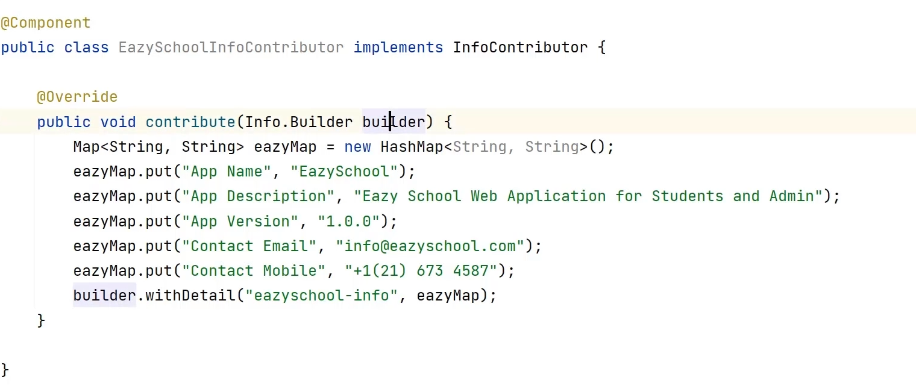

You can also define these properties in prop file

We can add these properties in custom property file

Import the custom property file using

@PathSource and read the properties using @ConfigurationProperties where it will assign it to the pojo and you can access from there

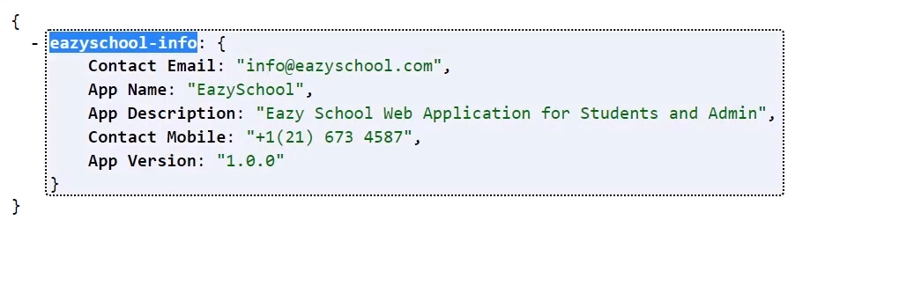

If we want to get beans related information then we can click below path

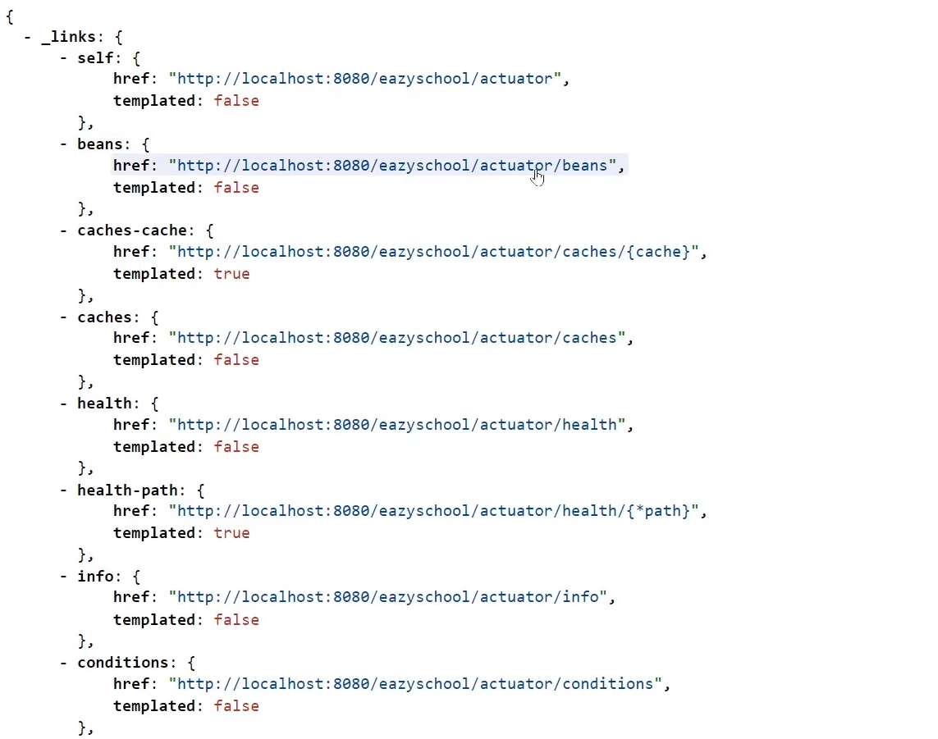

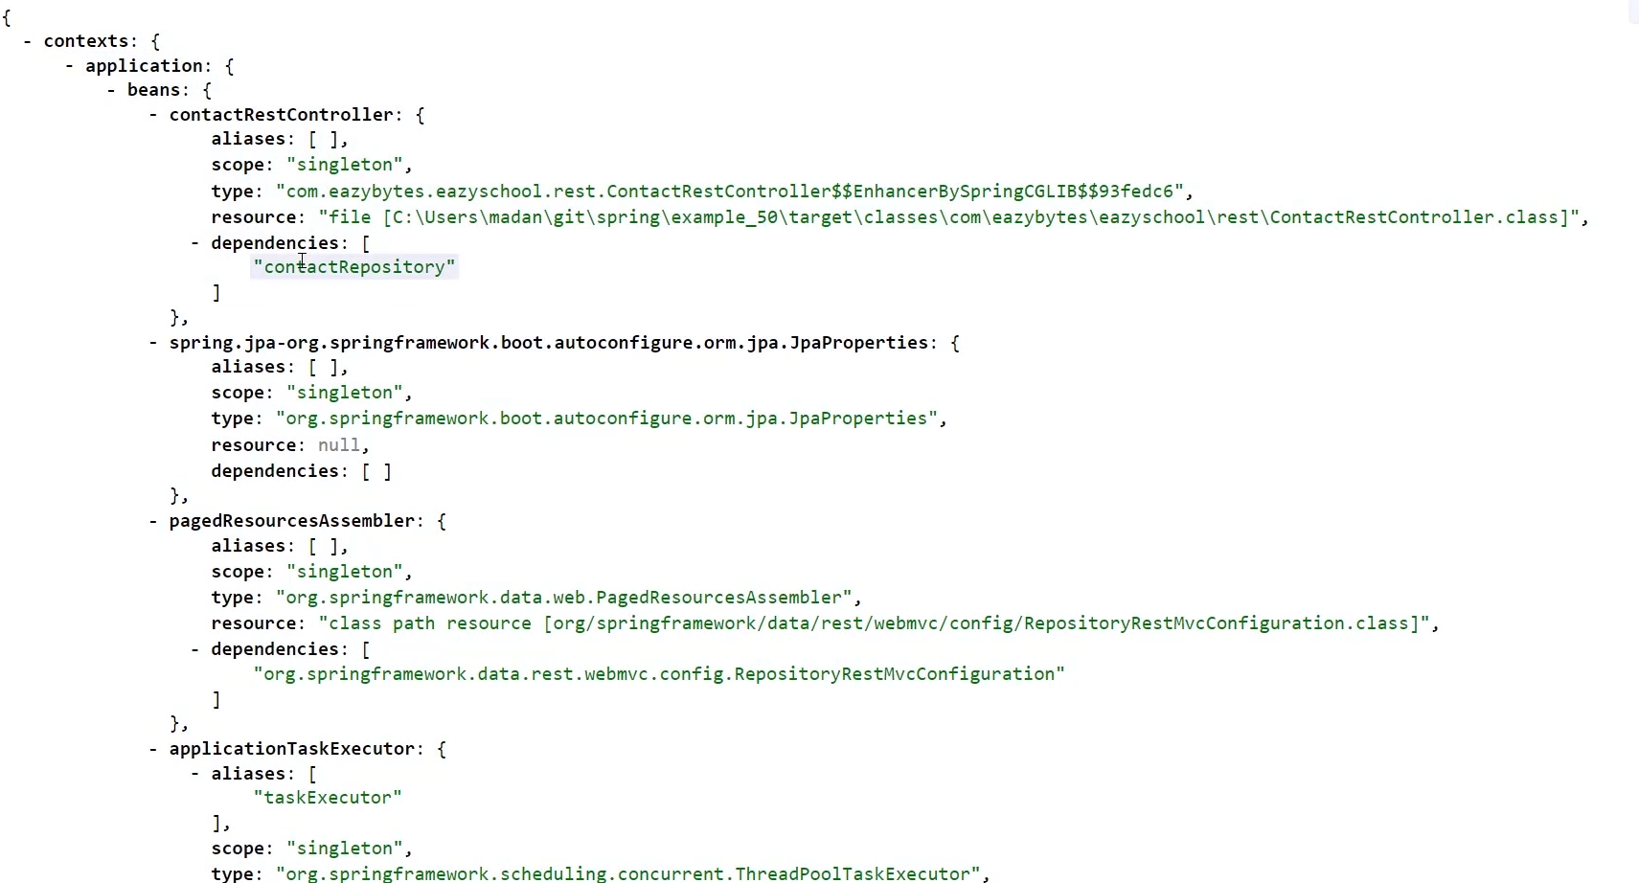

If we want to get autoconfiguration related info then click on conditions path

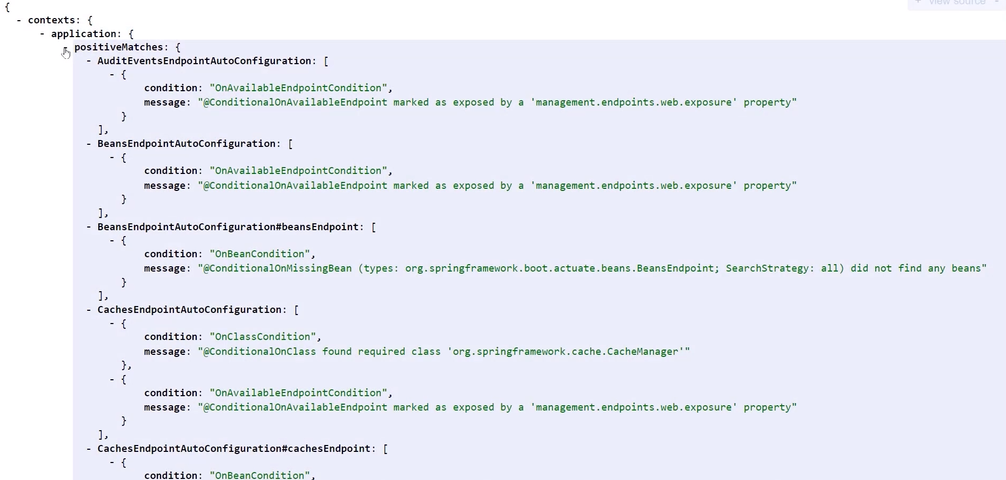

For properties related information which is by default provided by spring boot or user defined

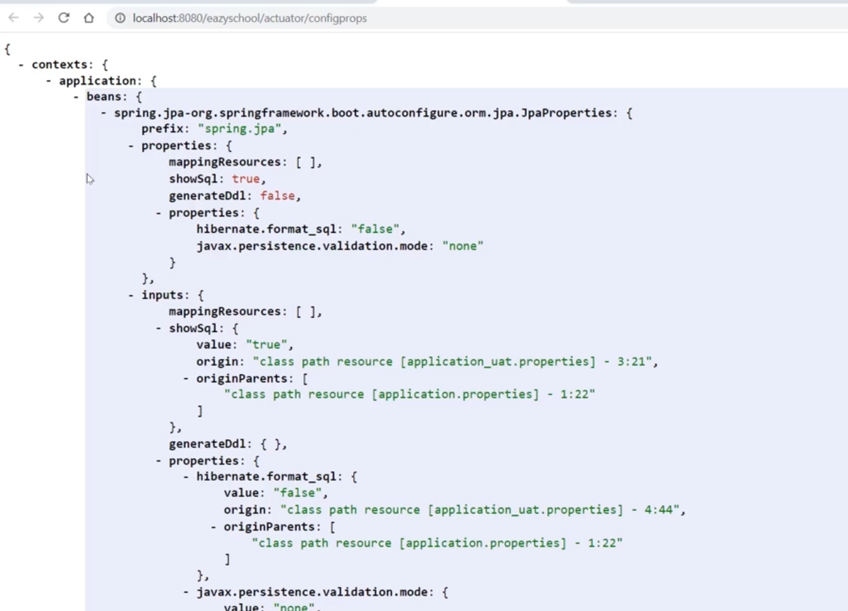

For Environment properties

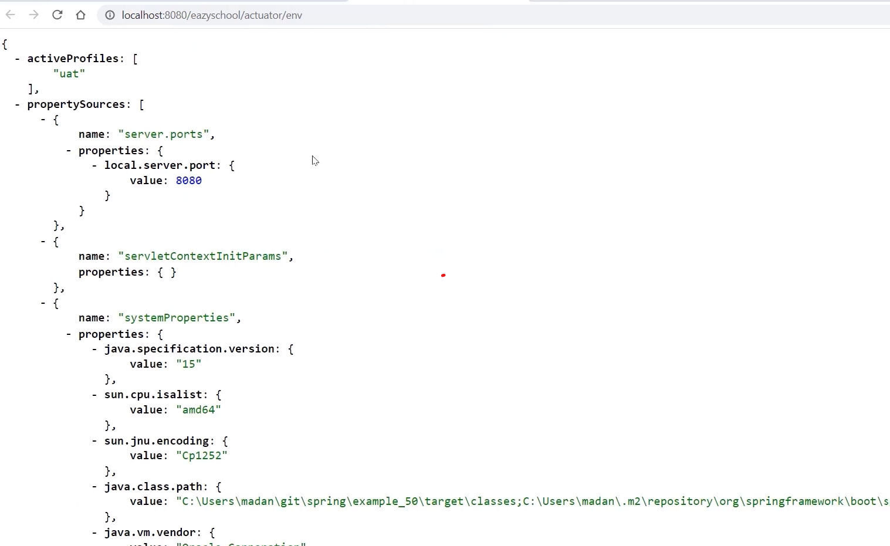

Also you can get the metrics information

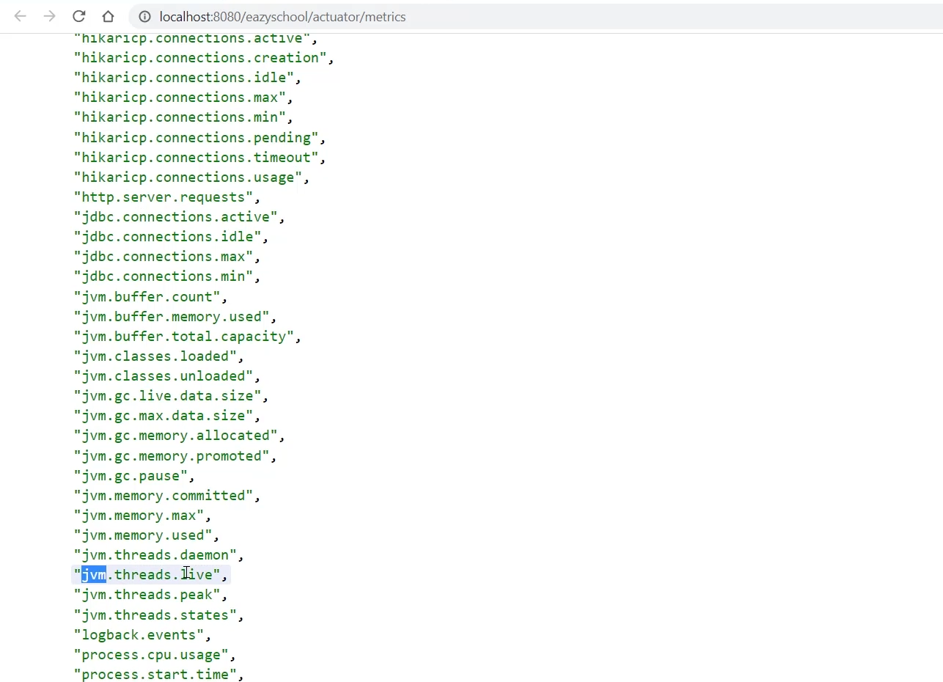

Now to access individual metrics just copy one and append it to metrics path as below

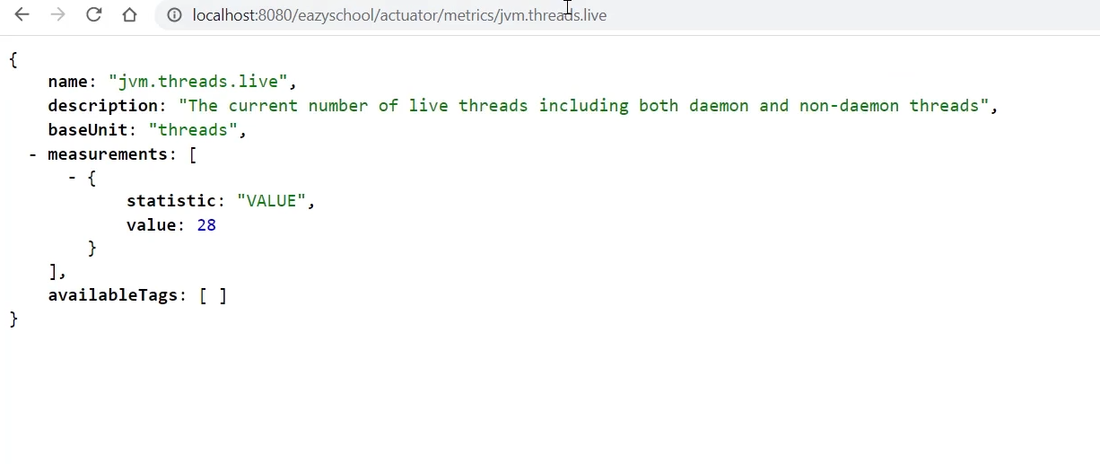

Also project is provided to read the data of these metrics in a human readable form by code centric on github

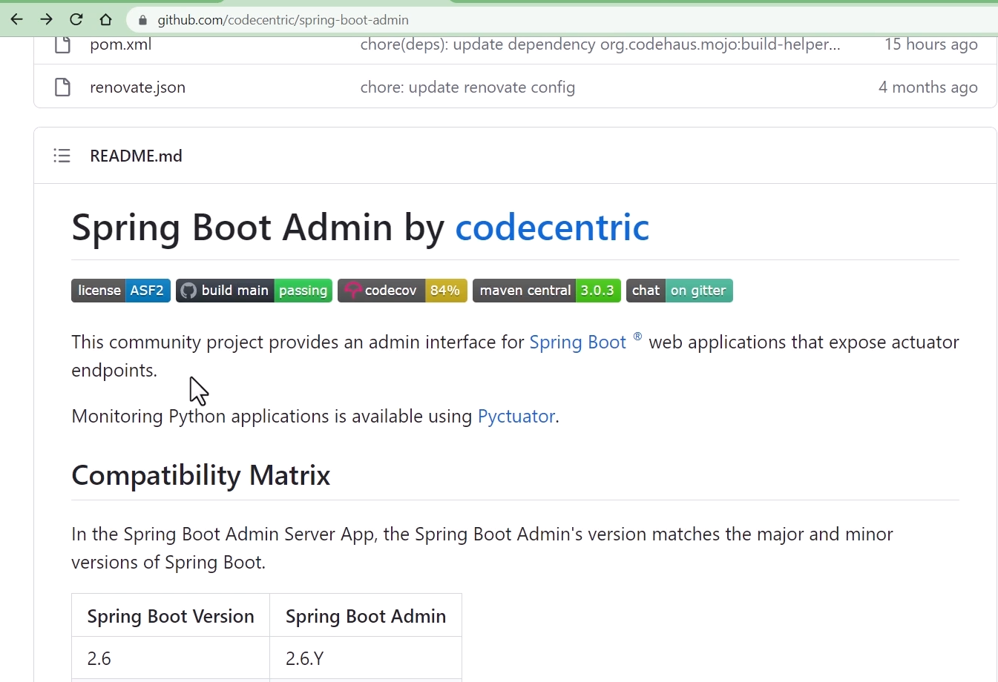

We can build this by using codecentric jars

First we need to build the server where it displays the actuator related information and client which sends data to actuator

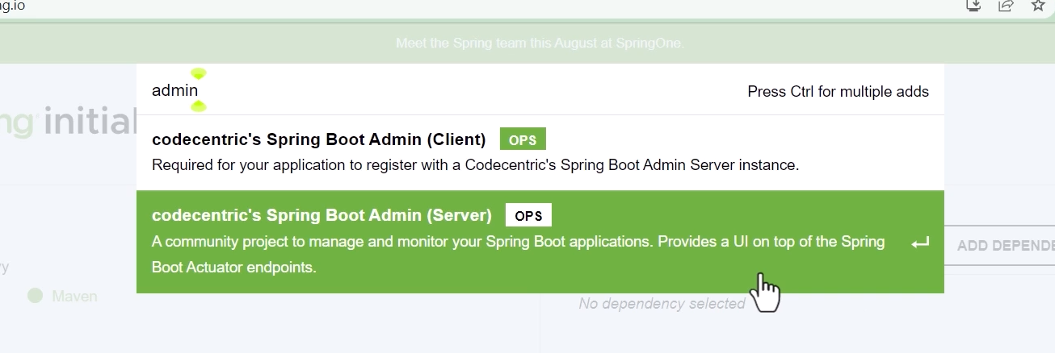

2 jars provided by codecentric

Lets create server application

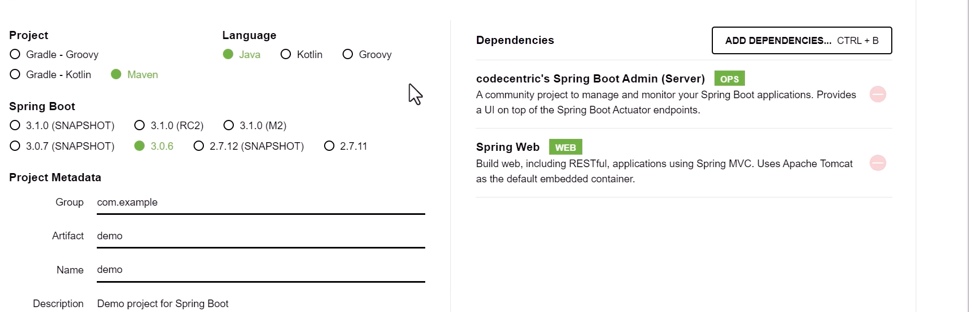

Then in main class we need to add @EnableAdminServer

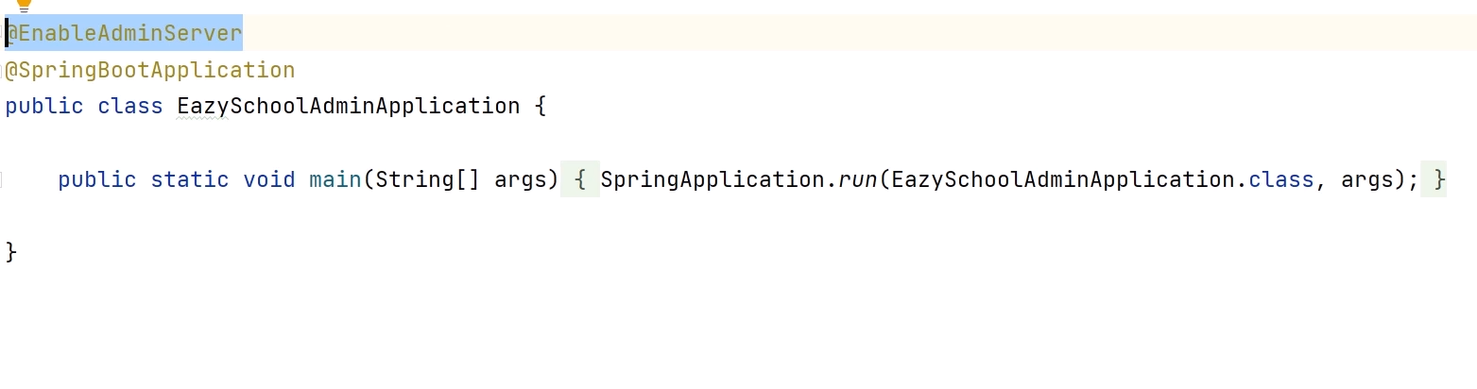

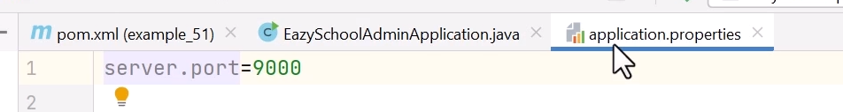

Now start the application

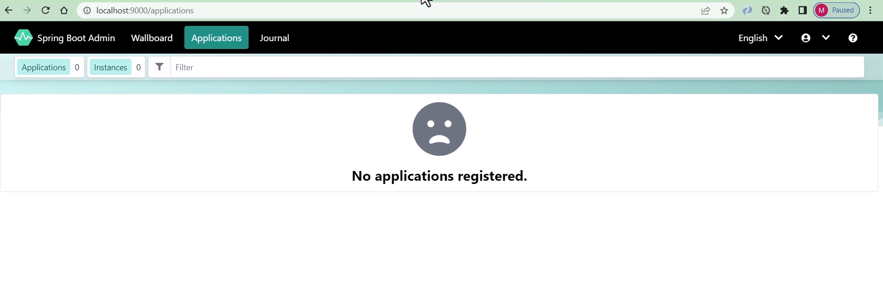As of now there are no clients registered to it

To make the clients to register add codecentric client to your springboot application as below

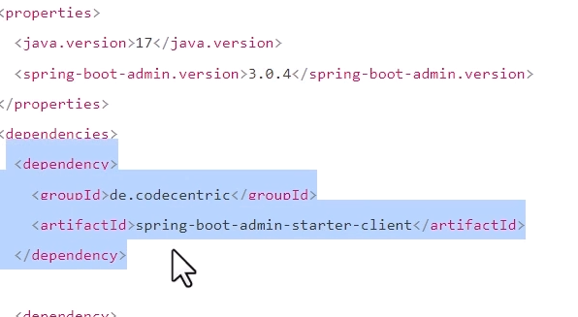

Also add below dependency management

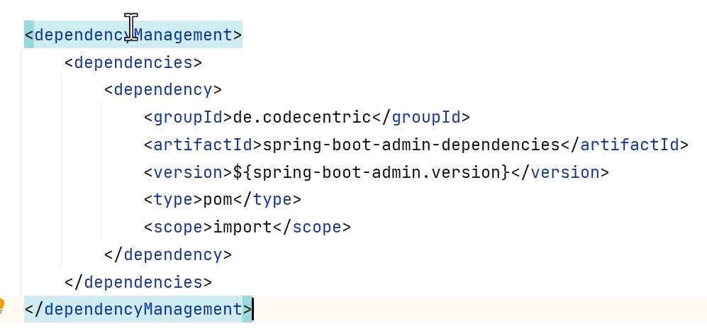

This you can do this by going to spring.io add codecentric client and click on explore button to open pom.xml and copy above dependencies in your application

Then add below dependency

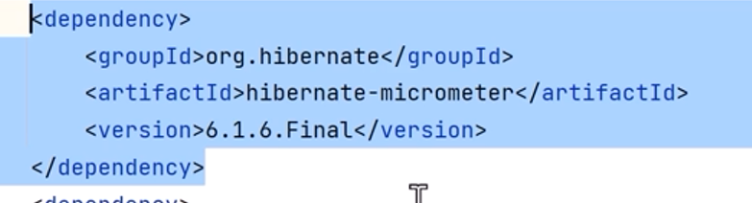

This will send info to server

Then add properties in prop file

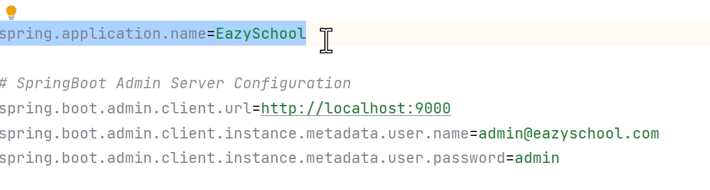

Now if you go back to server you will application registered

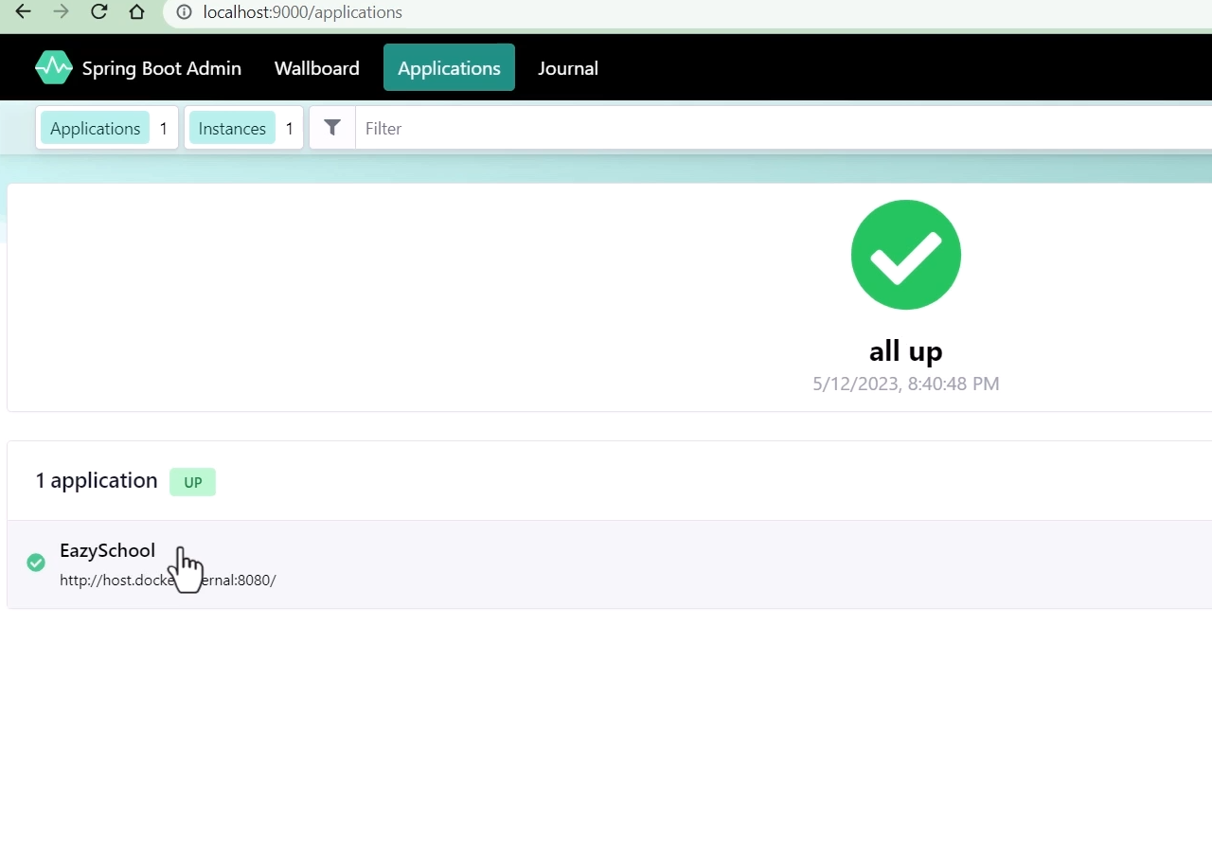

Now click on wallboard and click on your application

You will see all below details in readable format

